*Han Yibei*

*Shanghai Jiao Tong University, Dongchuan Road 800*

*Shanghai*

*China*

*Email: hyb_2001@sjtu.edu.cn*

*Dec.12 2020*

Editor xxxxxx

xxxxxxxxxxxx Inc.

Dear Editor,

From the past experiments, I’ve accumulated much experience and got acquainted with the experimental setup and procedure. I am so thankful that Vc211 has offered me a chance to conduct and report an experiment by myself or in a group.

I have searched online, looking for various ways to detect the concentration of ${ Cl}^{-}$. Many of them are out of my knowledge range so I spent a lot of time learning the mechanisms of the methods. However, since I want this report to be correct and scientific, I choose the most familiar method I am with, which is titration. It is also the one that is the easiest to conduct. I had much confidence in writing this report because I have a good command of the principle and procedure of titration. I’m glad that I can apply my knowledge to a real life problem and design the experiment by myself.

This report indicates my independent thinking and scientific literacy which have been cultivated by the course Vc211. I really cherish this chance to write an independent report, and thanks for Dr. Sun’s teaching, which gives me much help.

Yours sincerely,

Han Yibei

**Experiment 6: Chloride Ion in water**

Han Yibei

[Date Dec. 11, 2020]

Student ID 519370910123

Section 3

Group 3

Group Members Shen Kaixin

Zhang Zongkai

Lu XInyi

Telephone 18918329709

Email Address hyb_2001@sjtu.edu.cn

University of Michigan – Shanghai Jiao Tong University Joint Institute (UM-SJTU JI)

1. **OBJECTIVES**

* Know how to operate filtration
* Know how to make standard solution
* Knowhow to determine the concentration of chloride ion
* To understand the error and calculation method of the molar method for chloride ion measurement

1. **INTRODUCTION**

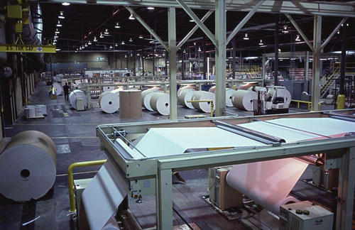The content of chlorine ions in water is directly related to people's healthy life and production activities. Many production departments, such as papermaking, construction materials and manufacturers of stainless-steel products, have a particularly high-quality requirement for water because of the serious erosion effect of chlorine ions on these materials.

Now most tapping water disinfection by chlorination process, the main purpose of the public water supply chlorinated water is to prevent sexually transmitted diseases, the method of expansion so far has 100 years of history, has a perfect production technology and equipment, chlorine for water disinfection has the disinfection effect is good, low cost, the advantages of almost no harmful substances. However, after understanding and studying the theoretical data, it is found that chlorine gas has some disadvantages in the disinfection of tap water. Chlorination disinfection of tap water can produce carcinogens. At present, experts concerned have also put forward many improvement measures.

1. **BACKGROUND**
2. **Filtration**

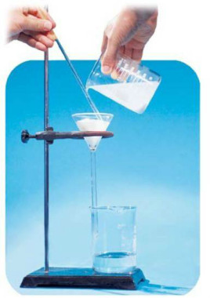Filtration is a process of purifying fluid through special devices. There are many filtration methods and a wide range of material systems. Solid-liquid, solid-gas, large particles, and small particles are very common.

Filtration is the most commonly used method of separating the solution from precipitation. When a mixture of solution and precipitation passes through a filter (such as a filter paper), the precipitation remains on the filter and the solution flows through the filter into the receiving container. Filtration in the traditional sense refers to the separation of solid and liquid by using porous media to intercept solid particles in suspension. In addition to centrifugation, bacteria, cells, and their fragments can also be separated by conventional filtration

1. **Titration**

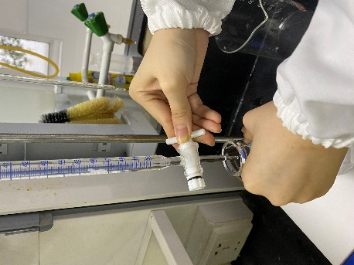 Titration is a means of quantitative analysis as well as a chemical experimental operation. It determines the content of a solute by a quantitative reaction between two solutions. It indicates the end point of titration according to the color change of indicator, then visually measures the volume of consumption of standard solution, and calculates the analysis result.

1. **Properties of Chloride**

Both $Cl^{-}$ and $CrO_{4}^{2-}$ react with $Ag^{+}$ to form precipitation, but the solubility of $AgCl$ is lower than that of $Ag_{2}CrO_{4}$. In the mixed system of $Cl^{-}$ and $CrO_{4}^{2-}$, $AgNO_{3}$ is added, and $Ag^{+}$ first react with $Cl^{-}$ to form $AgCl$ (white precipitation) until $Cl^{-}$ in the solution are basically consumed.

$$Cl^{-}+AgNO_{3}⇌AgCl↓+NO_{3}^{-}$$

Excess $Ag^{+}$ react with $CrO_{4}^{2-}$ to form silver chromate (brownish red precipitation). Thus, the presence of a brick-red precipitate means that the chloride reaction is complete, and the amount of chloride can be calculated based on the concentration and amount of silver nitrate.

$$K_{2}CrO_{4}+2AgNO_{3}⇌Ag_{2}CrO_{4}↓+2KNO_{3}$$

1. **Overview**

In this series of experiments, you will do filtration by your own. Test the amount of chloride through titration both in tapping water (if possible) and some NaCl solutions with unknown concentration.

1. **PROCEDURES**

**Part A.** **The filtration of tapping water**

Table 1: Chemicals and Materials Used in the filtration of tapping water

|  |  |
| --- | --- |
| Chemicals used | Materials used |
| Tapping water | Glass rod  Funnel  Beaker  Filter Paper |

|  |  |  |  |  |
| --- | --- | --- | --- | --- |
| Filtration sample | #1 | #2 | #3 |  |
| Origin Volume |  |  |  |  |
| Final Volume |  |  |  |  |
| Filtration Ratio |  |  |  |  |

1. Fold the filter paper in half, then fold again, and place into the funnel
2. Attach the bottom of the funnel to the side of the beaker
3. Drain with a glass rod and pour the liquid into the filter paper with the page lower than the top of the filter paper lower than the top of the funnel

**Part B. Titrating to calculate the concentration of $Cl^{-}$**

**B.1 Preparation of Standard Solutions**

Table 2: Chemicals and Materials Used in preparation of Standard Solutions

|  |  |
| --- | --- |
| Chemicals used | Materials used |
| NaCl | 50- mL Volumetric flask  Electronic balance  Beakers |

|  |  |  |  |  |  |
| --- | --- | --- | --- | --- | --- |
| Standard Solution | #1 | #2 | #3 | #4 |  |
| NaCl (g) |  |  |  |  |  |
| Concentration(M/L) |  |  |  |  |  |

1. Based on the calculation, take certain amount of NaCl.
2. Dilute the stock solution by filling the volumetric flask until the meniscus reaches the mark
3. Repeat step 2 for each of the six standard solutions 2# - 6# but pipet the corresponding phosphate volume from the table instead of that shown by Step 2.

**B.1 Titrating to calculate the**

Table 3: Chemicals and Materials Used in Part C

|  |  |
| --- | --- |
| Chemicals used | Materials used |
| 0.1M $AgNO_{3}$ Solution  0.5M $K_{2}CrO_{4} Solution$ Nacl solution with unknown concentration | Burette and burette stand  250-mL Erlenmeyer flask  100-mL Beaker (2)  25-mL Pipet w/bulb & graduated cylinder |

|  |  |  |  |  |
| --- | --- | --- | --- | --- |
| Titration Process | #1 | #2 | #3 | #4 |
| Start Volume |  |  |  |  |
| End Volume |  |  |  |  |
| Titrate Volume |  |  |  |  |
| Ag Concentration |  |  |  |  |
|  |  |  |  |  |
| Titration Process of tapping water | Tiral 1 | Trial 2 | Standby Trial |  |
| Start Volume |  |  |  |  |
| End Volume |  |  |  |  |
| Titrate Volume |  |  |  |  |
| Ag Concentration |  |  |  |  |

1. Run about 25.0 mL of deionized water through a 50-mL burette and then rinse the burette with $AgNO_{3}$.
2. Drop 10 drops of 0.5M $K_{2}CrO_{4}$ Solution into each
3. Use a funnel to add the labelled 0.1 M $AgNO_{3}$ solution into the burette and fill it up to near below the top mark. Drain any air bubbles from the tip of the burette into a wastebeaker. Record the initial volume V1.

4. Pipet 25.00 mL of the solution in step before

5. Slowly add the NaOH solution, drop wise from the burette to the tapping water and NaCl solution, swirling the flask after each addition. Continue until the endpoint is reached. Record the final volume V2.

6. Repeat steps for several trials.

1. **PRE-LAB EXERCISES**
2. How to make filtration process more accurate.

Answer: Attach the bottom of the funnel to the side of the beaker to reduce waste water. Drain with a glass rod and pour the liquid into the filter paper with the page lower than the top of the filter paper lower than the top of the funnel to reduce the waste of origin solution to filtrated solution.

1. When to finish the titration

Answer: After seeing brownish red precipitation.

1. After titrating 100ml 0.1M $AgNO_{3}$ solution into 25ml NaCl solution with unknown concentration, we can see the brownish red precipitation. Please calculate the concentration.

Answer: Amount of $Ag^{+}=0.1×\frac{100}{1000}$ =0.01M

So, the amount of $Cl^{-}$ is $0.01M$

The concentration is $\frac{0.01}{\frac{25}{1000}}$

1. What may be the problem while titrating the tapping water?

Answer: The concentration of chloride may be too little.

1. **POST-LAB ANALYSIS**

**OBSERVATION**

**The observation of filtration**

Find the relationship between filtration speed and the amount of origin solution

**The observation of NaCl**

Find the relationship between required solution volume and the concentration of NaCl Solution

**DATA ANALYSIS**

**The transformation ratio of filtration**

Repeat several times and take the average

**The certain concentration of unknown NaCl solution**

Calculate by the titrating conclusion

**The certain concentration of tapping water**

If possible, calculate the concentration of Cl in tapping water from the experimental output

**DISCUSSION**

When conducting the experiment, some factors may affect the accuracy of the data.

Factors resulting in a larger value of concentration:

* The volume of AgNO3 recorded is less than the actual value. This error might result from misreading of V1&V2 and the improper control of the end point.
* The temperature may be differed from the working temperature.

Factors resulting in a smaller value of concentration:

* There are still solids existing in the flask during dissolution, which means the solution itself has small concentration.
* When transferring the NaCl into the flask, some of the mass is lost.

The filtration process may have these error:

* The glass rot, funnel and beaker may not closely touch each other
* The surface of water, filtrating paper and funnel must be directly from up to above.
* There should be no broken on the paper

1. **DATASHEET**

|  |  |  |  |  |  |
| --- | --- | --- | --- | --- | --- |
| Filtration sample | #1 | #2 | #3 |  |  |
| Origin Volume |  |  |  |  |  |
| Final Volume |  |  |  |  |  |
| Filtration Ratio |  |  |  |  |  |
|  |  |  |  |  |  |
|  |  |  |  |  |  |
| Standard Solution | #1 | #2 | #3 | #4 |  |
| NaCl (g) |  |  |  |  |  |
| Concentration(M/L) |  |  |  |  |  |
|  |  |  |  |  |  |
| Titration Process | #1 | #2 | #3 | #4 | Unknown |
| Start Volume |  |  |  |  |  |
| End Volume |  |  |  |  |  |
| Titrate Volume |  |  |  |  |  |
| Ag Concentration |  |  |  |  |  |
|  |  |  |  |  |  |
| Titration Process of tapping water | Tiral 1 | Trial 2 | Standby Trial |  |  |
| Start Volume |  |  |  |  |  |
| End Volume |  |  |  |  |  |
| Titrate Volume |  |  |  |  |  |
| Ag Concentration |  |  |  |  |  |

1. **REFERENCE**

Nie, Ming. “Experiment on Chloride Ion Content of Concrete Structure in Coastal Salt-Fog Area.” MATEC Web of Conferences, vol. 67, 1 Jan. 2016, p. 07016., doi:10.1051/matecconf/20166707016.

Teng, Haiwen. “Chloride Ion Erosion Experiment Considering Loads.” 2011 International Conference on Electric Technology and Civil Engineering (ICETCE), Apr. 2011, pp. 4866–4869., doi:10.1109/ICETCE.2011.5776537.

Peter Atkins, Chemical Principles The Quest for Insight Seventh Edition, Macmillan education, 2016.

VC211 Laboratory Manual, UM-SJTU JI &SJTU Chemistry Department, 2019-2020.